BCIS-5610 DATA WAREHOUSING
BY
PROF KASHIF SAEED

Assignment 4 – Tableau Workbook on Dimensional Model

BY
SAI SNEHA AARIGA

My SQL WORKBENCH
USERNAME: Root
PASSWORD: Snehasai@97
DATA SOURCE:
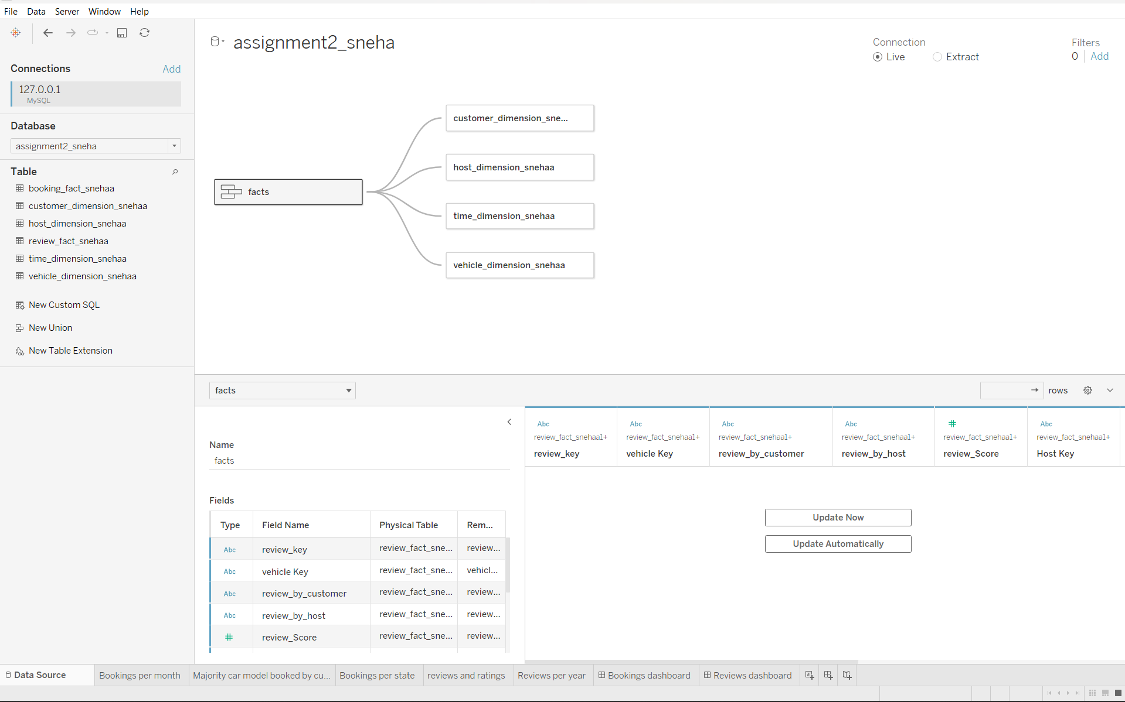

How did you connect to the MySQL database? How did you resolve the loop(s)? (2.5 points)
The following are the actions taken to connect to data:
- Open Tableau Application.
- Connect to data by selecting My SQL from the 'To the Server' menu on the left.
- Choose the database that you wish to import.
- Enter My SQL Work Bench Credentials and click Sign In
After importing the tables, I dragged the necessary tables onto the data source pane.
The two fact tables (booking and review facts) were combined, and the four dimensions (Customer, host, vehicle, time dimensions) were added to the newly formed union. Tableau does not support loops; hence we are unable to fix them. To fix this problem, I made a union for fact tables and joined them with dimensions.
Document the workarounds. Why did you need one? How does the work around work? Is this work around applicable in the industry? (for example, exporting the data from MySQL to Excel is not a workaround that will be applicable to the industry) (2.5 points)
In QlikView, it has Semantic layer which provides the users with a drag and drop interface for analysis. Tables were imported into QlikView using a SQL script, and synthetic keys were eliminated by using the 'AS' keyword if the fields had different names.
In the case of Tableau, there is no semantic layer, so the workaround is done by union method where tables are imported from the database, two fact tables are combined and made as union. The dimension tables are joined with the newly formed union.

WORKSHEETS:
- Bookings Per Month:

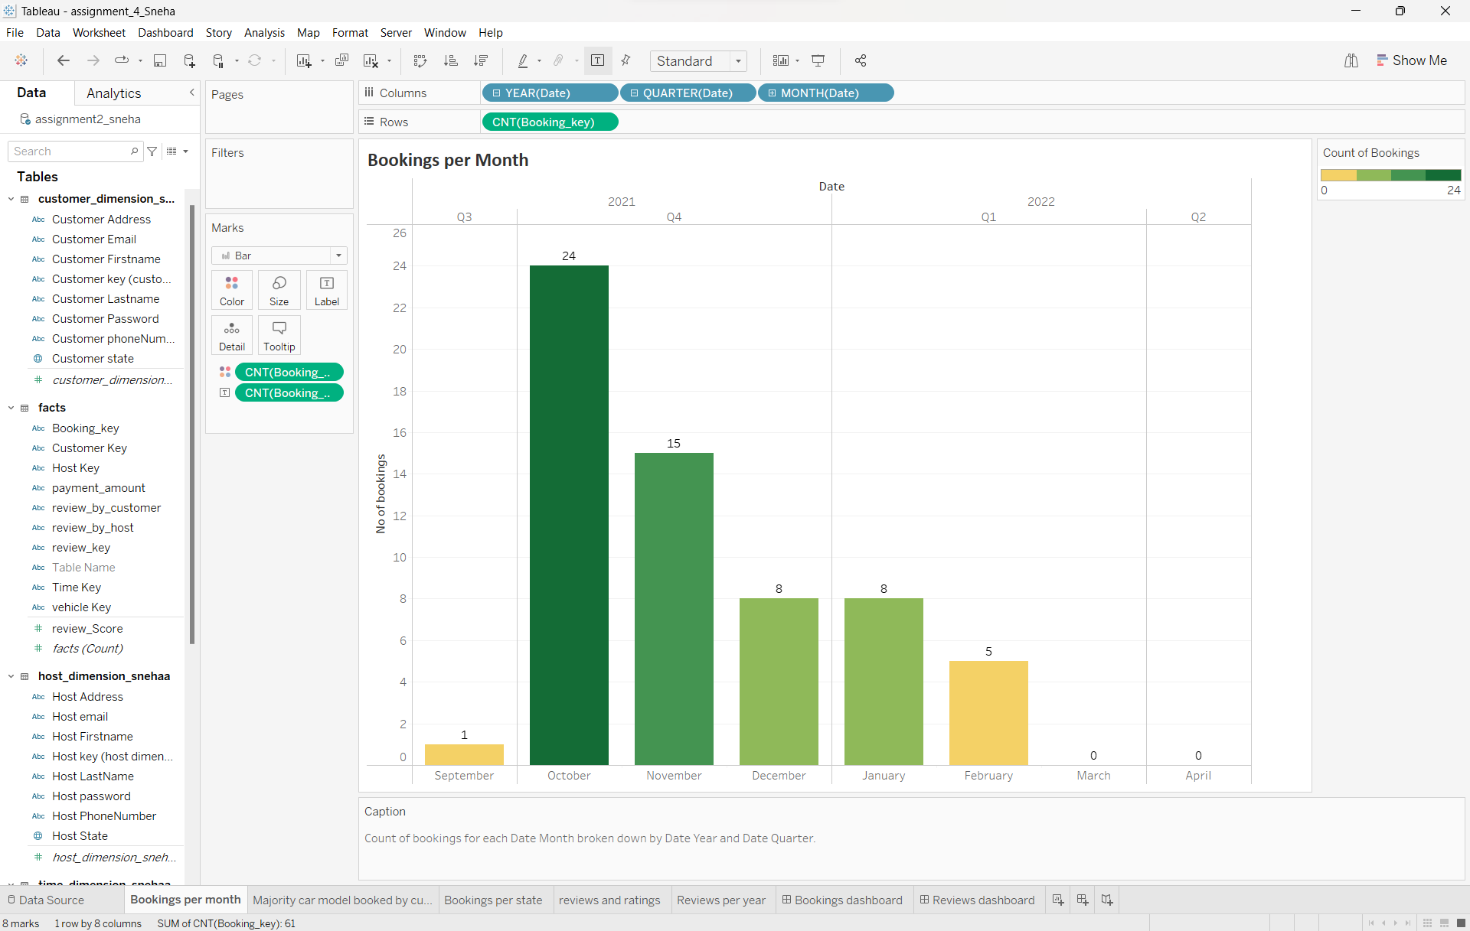

- Majority car model booked by customer:

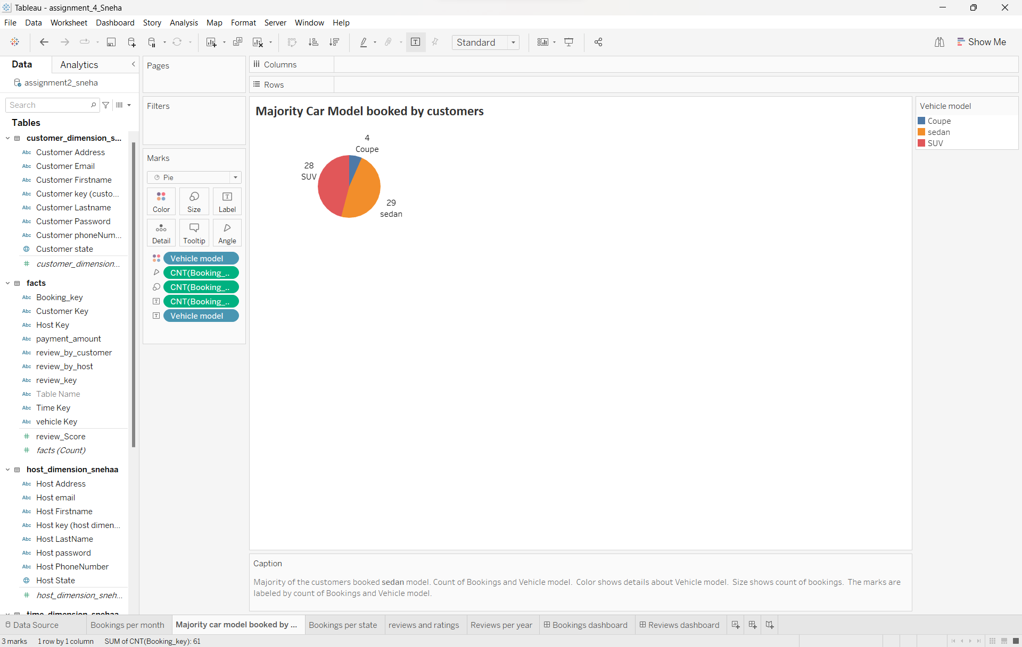
- Bookings per State:
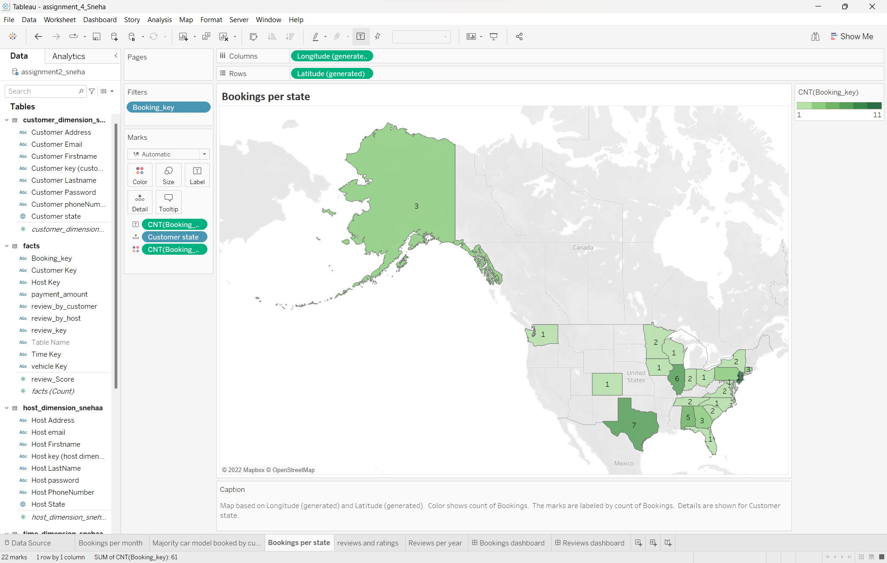

- Reviews & Ratings:

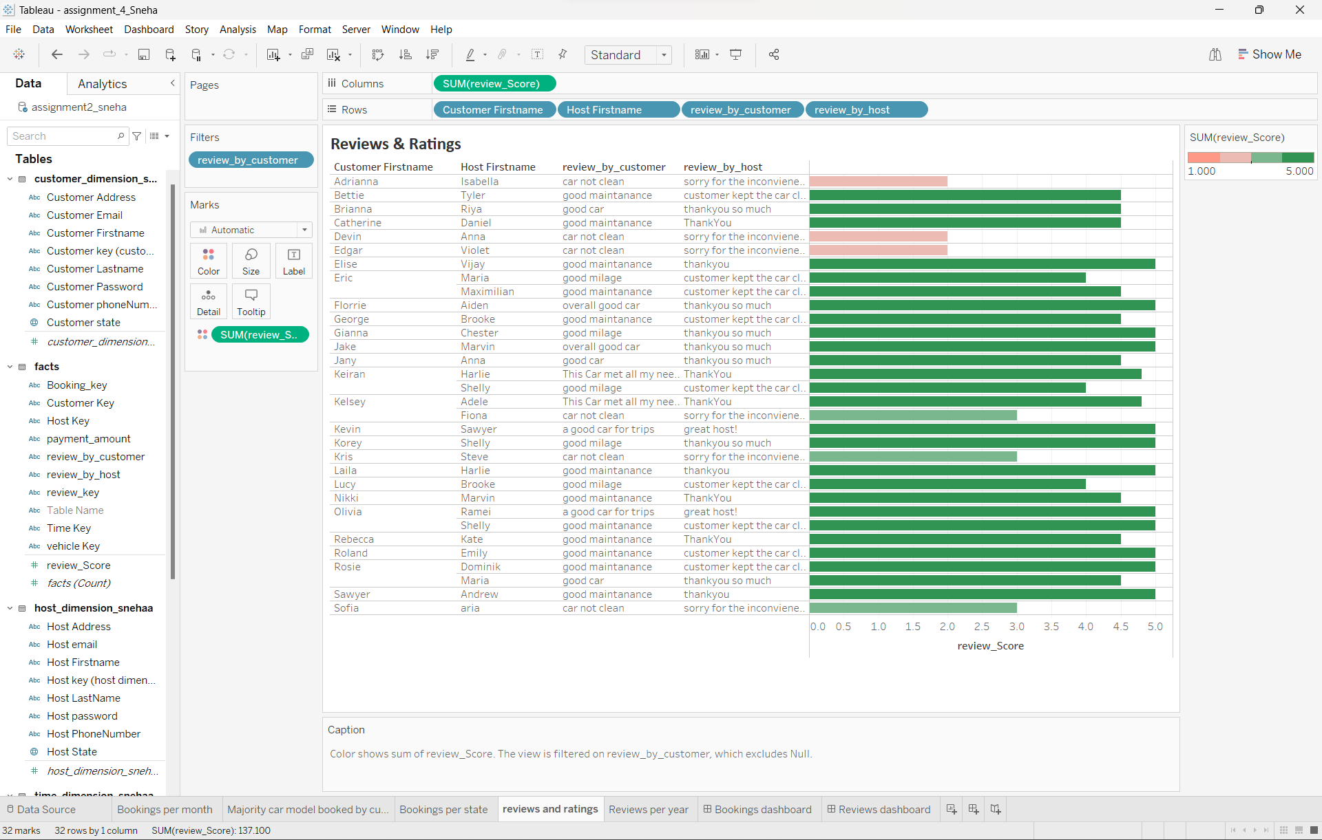
- Reviews Per Year:
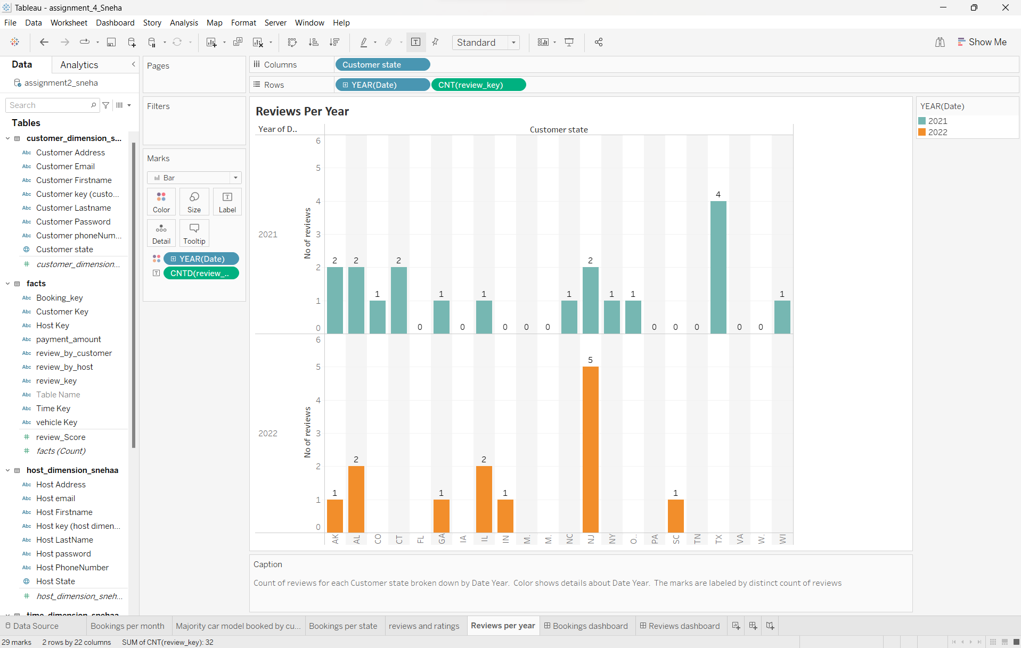
DASHBOARDS:
1.Bookings Dashboard:
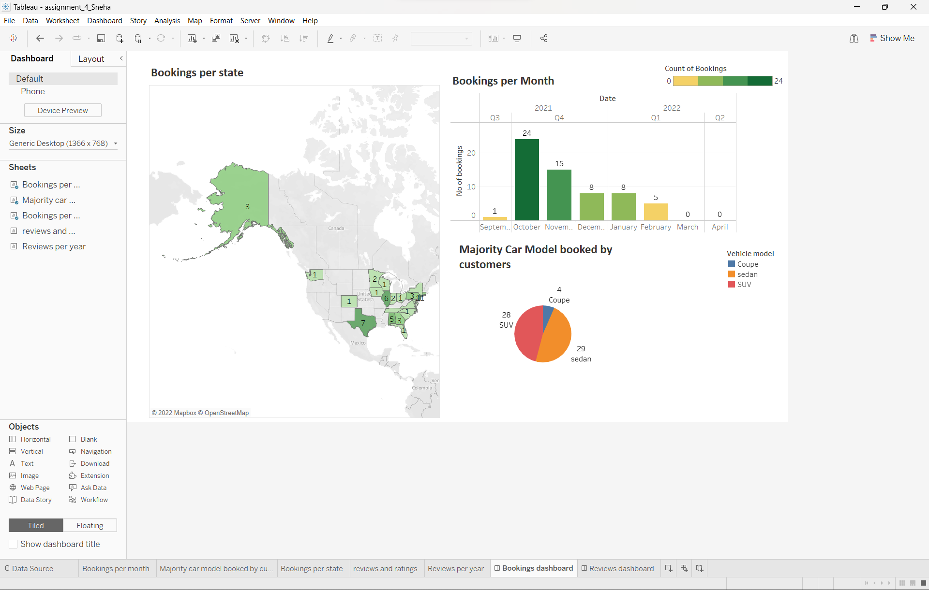

2. Reviews Dashboard:
